Software Requirements Specifications Document of an Integrated Fleet Management System (IFMS)

(Version1.0)
for Ministry of Transport and Logistics Ethiopia
Version 1.0 – 25th September 2024

Content

System Requirements Document 1
Content 2
1. Introduction 4
2. Scope and Deliverables 4
2.1. Scope of Work 4
2.2. Deliverables 5
2.3. Functional Requirements 5
a. Fleet Management 5
b. Admin 32
2.4. Non-functional Requirements 40
2.5. Assumptions 40
3. Timeline and Cost 42
3.1. Timeline 42
3.2. Milestones 42
4. Proposed Technology 45
4.1. Development Environment 45
5. Proposed Workflow 46
5.1. Management Methodology 46
5.2. Design Workflow 48
5.3. Development Workflow 50
5.4. Testing Workflow 51
5.5. Testing Scope 54
5.6. User Acceptance Testing 54
6. Working Principle 55
6.1. Smartwatch Solutions Ltd Responsibilities 55
6.2. Client Project Management Responsibilities 56
6.3. Working Time and Holidays 56
Working hours: 56
Holidays: 56
6.4. Management Tool & Communication Channel 57
6.5. Communication Plan 57
7. Contract Type and Invoice Procedures 57
8. Points of Contact 57
9. Acceptance 58

Introduction
The project aims to develop a solution for Ministry of Transport and Logistics Ethiopia (MOTL) to efficiently manage and monitor their fleets. The Integrated Fleet Management System (IFMS) will provide real-time tracking, performance analysis, and reporting capabilities to optimize fleet operations and enhance productivity.
The system is designed to address various challenges in the transportation industry, including inefficient route planning, poor asset utilization, lack of vehicle visibility, Geo-fencing, vehicle maintenance, compliance, and safety concerns.
The solution comprises two distinct portals: the Fleet Management System (FMS) and an administrative panel.
The Fleet Management System will be developed as a web-based application and a mobile application for user convenience.
1.1Purpose
The purpose of this SRS document is to specify software requirements of the integrated fleet management system. It is intended to be a complete specification of what functionality the system provides. The main purpose of the system is to automate fleet management within the ministry of logistics and transport. The solution will provide for real time monitoring of trips, efficiency of freight capacity through reduction in idle time, reducing delays and also providing sector statistics for analysis in support of decision making and policy adjustments. Specific design and implementation details will be specified in a future document.
1.1.2 Document Conventions
Items that are intended to stay in as part of your document are in bold
Explanatory comments are in italic text
Plain text is used where you might insert working about the project
1.2 Product scope
This project is aimed for implementation of the Integrated Fleet Management System (IFMS) that will cover all vehicles involved in the movement of goods controlled and within the purview of the Ministry of Transport and Logistics (MOTL), ensuring effective fleet management aimed at reducing and minimizing overall costs through maximum, cost effective utilization of these important and valuable resources.
The implemented system in this project will offer a wide range of functionalities, including but not limited to:
- Design, development and deployment of the integrated fleet management system (IFMS). This will be a software solution covering the aggregation and presentation of information from all registered GPS service provider systems as well as the reporting and analytics functionality.
- Design, development and deployment of Application Programming Interfaces that shall integrate to:
- Multiple GPS service providers (at least 40)
- Integrated Transport Management System (ITMS)
- RFID and NPR based system at checkpoints on the Djibouti Addis Corridor
- Other integrations that will be identified in the design stage of the project.
- Delivery of an enterprise service bus to manage these integrations will be part of the scope of implementation. This component will enable the full implementation of the scope item 2 listed above.
- Support Geofencing of the Ethiopia-Djibouti corridor. This will involve mapping the virtual geographic boundary, as well as specific points of interest, enabling system to trigger a response when a truck enters or leaves areas on the corridor.
- Knowledge Transfer / Capacity building by training MoTL staff and other users on best practices of the system.
- Support & Maintenance, System Updates & Updates.
- Real-time monitoring of vehicle status, encompassing key parameters such as state (moving, parked, idling), location, speed, events, and geo-fencing. It will also track historical trips and provide fatigue management features.
- Enhancing the efficiency of freight capacity by reducing idle time through features like speed zone management, and geofencing.
- Minimizing delays in transporting critical public cargo by implementing an effective scheduling system. MOTL will have the capability to locate the nearest unassigned vehicle, enabling prompt responses to urgent tasks
- Providing comprehensive sector statistics for analysis, facilitating decision-making and policy adjustments. Through detailed reporting, the system will offer vital information to MOTL, including carbon emissions from each vehicle, odometer and total kilometers covered, vehicle service history, license renewal dates, inspection records, and more
- Additionally, we propose an app compatible with both iOS and Android, providing convenient access to the fleet management system.

The following are the deliverables of the system.
- Assignment Plan: Develop and implement an end-to-end software development plan that will be used at different stages of the assignment.
- Prototype: Develop models that will be used to actualize the SRS and SDS; refine the requirements, capture emerging issues and get early stage feedback from users.
- Functional System: Develop an intuitive solution using current Web based technology and nonproprietary software platforms (open source) that are compatible with mobile/portable gadgets.
- System Interfaces Deployment: Develop and deploy the integrations as specified in the scope.
- System Testing: Undertake various system tests in line with best practice and based on definite standards that will guarantee quality of the solution developed.
- vii. Geofencing of the Ethiopia-Djibouti corridor. The consultant will work with the MOTL technical staff to geofence the route as well as specific point of interest along it.
- System Training: Conduct various types of trainings (ordinary users, advanced users, training of trainers etc.) for all users who will be using the new system.
- Hosting and Operations Specifications: Define the optimal and ideal hosting and operational ICT infrastructure requirements for the developed solution for MoTL.
- System Deployment: Deploy the solution developed to the final hosting environment, migrate existing data from the current form and ensure the system is able to operate at its optimal capacity with all the interfaces working.
- System Documentation: Document all the aspects of the solution at the various stages of development. In the scope and methodology, all required documentation of the associated stages is detailed.
- Support, Maintenance and Upgrades: Provide full support services during the guarantee/warranty period for the solution. The warranty period will not be less than 2 calendar years from the date of the sign off to the last module going live.

1.2.2 Project Objectives
Our understanding of the high-order objectives of this project are that Ethiopia wants to:
- Significantly boost intra-regional trade across key markets for Ethiopia
- Provide real-time visibility of freight traffic on transport corridor operations
- Enable targeted interventions to alleviate bottlenecks
To achieve these objectives, we proposed to deploy and customize an integrated fleet management system (the IFMS), which is a GPS-based vehicle fleet tracking system (VFTS) that will enable Ethiopia to oversee, coordinate, and facilitate various transport and transport-related activities.

1.3 Abbreviations and Definitions
MoTL-Ministry of Transport and Logistics
IFMS-Integrated Fleet Management System
ITMS-Integrated Transport Management System
GPS-Geographical Positioning System
GPDR- General Data Protection Laws
RFID-Radio Frequency Identification
NPR-National Public Radios
API- Application Programming interface
FE-Front End
DB-Database
CRUD-Create Read, Update,Delete
Geozone- Geographical Area/Zone
CSV-Comma Separated Values
SMS-Short Messaging Service
JSON-JavaScript Object Notation
UTF-Unicode Transformation Format
AI-Artificial Intelligence
ML-Machine Learning
GDPR-General Data Protection Regulation
UI/UX-User Interface/User Experience
QC-Quality Control
UAT-User Acceptance Testing

1.4 References
- http://msdn.microsoft.com/en-us/library/ms130214
- http://www.chambers.com.au/glossary/software_requirements_specification.php
- https://www.cleveroad.com/blog/fleet-management-software-development/
- https://www.collegelib.com/fleet-management-software-development/

1.4.1 Technologies
• Jakarta EE: The successor to JavaEE, known for its enterprise features and community-driven enhancements.
• Angular 16: The latest version of Angular, allowing for dynamic and responsive web applications.
• Micro Profile 6.0: Focusing on Microservices architecture for optimum scalability, adapting to varying workloads with ease.
• PostgreSQL 15: Recognized as one of the most advanced open-source relational databases, ensuring performance, reliability, and extensibility.

1.5 Overview
This Software Requirements Specifications document will include two sections.
Overall Description will describe major components of the system, interconnection and external interfaces.
Specific Requirements will describe the functions of actors, their role in the system and constraints.
Overall Description: The rest of this document will give further details on the overall product description, including the hardware, software, and communications interfaces, product functions, user characteristics, and any assumptions that will be made.
Specific Requirements: The document will also include the specific requirements needed. These will include the functions, performance, design, and software attributes. This document is organized in a logical manner and is easy to follow. Readers should refer to the table of contents, appendices, or index if looking for something in specific. Otherwise, reading this document from start to finish will start with a vague description and get more specific and detailed as changing sections and reading further.

Product overview

Product perspective

The system shall be intuitive, comprehensive and scalable that optimizes fleet operations, enhances driver safety, vehicle safety, and shall improve organization efficiency

The platform is going to be cloud based and on premise and will integrate real time vehicle tracking, fleet analytics, driver management, fleet operations for small to large sized vehicles operated by the fleet organizations.

The platform shall help Ministry of Transport and Logistics increase productivity and enhance safety with in its regulatory, it will help monitor the dedicated regional transportation and logistics companies plying through the corridor.
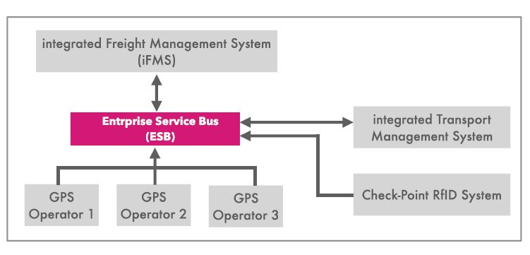

Product functions
Vehicle Tracking: Real time GPS tracking, location history, and geofencing which will be using GPS technology to monitor and track the location of, movement and status of vehicles in real time.
The key features shall be:
Refer to Table 2.4 Functions
  - Product Constraints
The product shall meet the integration forms of almost all GPS manufacturers that meet the IEEE and ISO standards for manufacturing electronics and that are licensed with in the regulation of the government of the republic of Ethiopia we however list that the product may face below constraints which are categorized in technical and functional, Operational and environmental and Social constraints.
    - Technical Constraints
- Hardware compatibility with GPS trackers, sensors ,RFID systems and other aggregation areas.
- Software compatibility issues within the integration areas with other aggregators arising from browsers, operating systems
- Network connectivity arising from third party cellular service providers, Wi-Fi spots and other challenges that may arise from network connectivity.
- Data Storage capacity and compatibility
- Integration with existing systems from other government stakeholders
- Compliance with industry standards such as GPDR,OSHA and other regulatory regulations like industry specific regulations and international regulations applicable with in the region.
- Browser and Device support

    - Functional Constraints
- Vehicle tracking accuracy and frequency from GPS service providers.
- Real time data updates from the GPS and RFID service providers.
- System automated reporting and alerts from third part aggregators
- User interface and User Experience
- Integration with third party services with in the industry and outside the industry
- Support for multiple drivers and users
- Customizable dashboards and workflows at implementation and user acceptance.
- Support for multiple drivers, users and the number of vehicle types GPS companies integrate with.

    - Operational Constraints
- Fleet size and complexity as a challenge arising from the amount of data being relayed and stored by the platform.
- Geographical coverage of GPS and RFID service providers with in the region
- Platform integration with existing business processes
- System uptime and reliability arising from the availability of the host environment and Network connectivity
- Compliance with regulatory requirements by service providers aggregating with the platform
- Subscriptions from end users /GPS companies that could put the platform off the system.

    - Environmental and Social Constraints
- User Acceptance and adoption for the platform due to the culture.
- Weather conditions and climate and terrain that could distablise the connectivity of the GPS and RFID devices thus affecting real-time data transmission for the platform.
- Road worthiness and infrastructure that could lead to loosening of GPS devices thus not communicating well with the platform
- Compliance with environmental and social regulations
- Organisational culture and change management from an social environmental perspective
- Stakeholder expectations and communication
- Customer satisfaction and experience
- Public perception and experience

  - User Characteristics
The platform shall address the following roles to identify users, responsibilities while meeting the needs and expectations of the IFMS to harmonise the platform while understanding the product perspectives and user characteristics.
The primary Users shall be categorised into two Regulatory and Service providers

Regulatory and Service providers
- Fleet Managers
- Operations
- Logistics officers
- Dispatchers
- Supply chain Managers
The Users shall be of experience with basic computer understanding and skills, able to articulate and explain system and platform performance and shall have understanding of fleet management software’s, with an a clear understanding of GPS and telematics with at least 2 or more years with in the regulator.
Users shall also be able to pay attention to detail with transport and logistic organisational skills, good communication skills problem solving skills.
Users shall be able to understand GPS real time tracking and be able to understand automated reporting, understand multiple GPS tracking user interfaces, customize dashboards and understand system integrations with third party aggregation systems.
Our understanding of these user characteristics and needs shall help the platform meet its goals which is crucial to in the designing and implementation of the IFMS that shall meet the requirements of the Ministry of Transport and Logistics.

  - Assumptions and Dependencies
The system shall be an on premise implementation or cloud otherwise a hybrid environment can be considered depending on the available host environment ,we have aligned a few dependencies and assumptions for system performance to deliver the required needs.
- Reliable internet connectivity for real time data transmission
- Accurate GPS tracking and geolocation data points from GPS service providers and the RFID system.
- User Adoption and Training
- Compliance with Regulatory frameworks
- Compatibility with various device types and operating systems running on those devices
- Adequate host environment to for system scalability for growing numbers from fleet operators
- Standardised vehicle communication protocols
- Integration with other aggregators and existing systems

For Proper reporting of the platform the following dependencies were identified
- Hardware
-GPS trackers
-Servers and data storage infrastructure.
- Vehicle Sensors
2. Software
- Operating systems -Windows or Linux platforms
-Database Management systems
-Integration with third party APIs
3. Regulatory
-GPDR
-Local and regional regulations
4. Third party Service providers
- Mapping and navigation service providers like google maps
-Traffic information providers and weather service providers.
5. Infrastructure
- Network connectivity
-Power supply
-Physical security
6. User Experience
-Fleet management experience
-Dispatchers knowledge
-Drivers
-Logistics officers
-Technical officers
-Maintenance personnels

  - Apportioning of Requirements
The requirements shall be apportioned as stated in the table below
Functional Requirements:
1.⁠ ⁠Vehicle Tracking (30%)
- GPS tracking
- Real-time location updates
- Geofencing
2.⁠ ⁠Fleet Management (25%)
- Vehicle assignment and scheduling
- Maintenance management
- Fuel consumption monitoring
3.⁠ ⁠Driver Management (20%)
- Driver profiling
- Hours of Service (HOS) tracking
- Driver behavior monitoring
5.⁠ ⁠Reporting and Analytics (10%)
- Customizable dashboards
- Real-time reporting
- Historical data analysis
Non-Functional Requirements:
1.⁠ ⁠Performance (30%)
- Response time
- System uptime
- Data processing speed
2.⁠ ⁠Security (25%)
- Data encryption
- Access controls
- Authentication
3.⁠ ⁠Usability (20%)
- User interface
- User experience
- Training requirements
4.⁠ ⁠Scalability (15%)
- System flexibility
- Data storage capacity
- User growth support
5.⁠ ⁠Integration (10%)
- Third-party API integration
- System compatibility
- Data exchange formats
Interface Requirements:
1.⁠ ⁠User Interface (40%)
- Web-based interface
- Dashboard customization
2.⁠ ⁠Application Programming Interface (API) (30%)
- Data exchange formats
- API documentation
- Integration with third-party systems
3.⁠ ⁠Hardware Interface (30%)
- GPS trackers
- Vehicle sensors
Performance Requirements:
1.⁠ ⁠Response Time (40%)
- < 2 seconds for user interactions
- < 5 seconds for data updates
2.⁠ ⁠System Uptime (30%)
- 99.9% uptime
- < 1 hour downtime per month
3.⁠ ⁠Data Processing Speed (30%)
- < 1 minute for data processing
- < 5 minutes for report generation
Security Requirements:
1.⁠ ⁠Data Encryption (40%)
- AES-256 encryption
- Secure data storage
2.⁠ ⁠Access Controls (30%)
- Role-based access control
- User authentication
3.⁠ ⁠Authentication (30%)
- Multi-factor authentication
- Secure login protocols

The apportion rationale is that for purposes of the assessed user needs and goals the functional requirements were given priority to address specific system capabilities and features of the IFMS ensuring that it meets the necessary business needs and goals whereas the non-functional requirements ensure performance, usability and system security we considered them to be secondary to this phase, these shall address issues of quality and performance, assurance while meeting the necessary required standards for usability, reliability and maintainability of the platform.

Interface requirements shall facilitate user interaction, system integration with the available aggregators and user adoption. They shall define how users and other third party systems, devices, ensure seamless communication and data exchange

The performance requirements shall define the expected operational benchmarks of the IFMS ensuring it meets the necessary standards of efficiency, reliability and user satisfaction to address issues of response time, system uptime, data processing speed, throughput, availability and scalability.

To manage the full development of the requirements, Smartwatch Solutions in JV with Kayu Technologies defines the following key activities for the project:

No. | Item Description
1 | System Analysis
2 | Architecture Design
3 | Visualization
4 | Development
5 | Testing
6 | UAT (User Acceptance Testing)
7 | Change Management
7 | System Piloting, data migration, and deployment
8 | Warranty

Deliverables
No. | Item Description
1 | Architecture design for the whole system
2 | Designs for the system
3 | Delivery of the Fleet Management Application.

Functional Requirements

Fleet Management

ID | Module | Feature/Screen | Description | Assumptions | Milestone
1 | Project skeleton setup |  |  |  | Milestone 1
2 | Database design and setup |  |  |  | Milestone 1
3 | Login/Log Out | Log in | - Forgot Password: User will receive email with the reset password link.  - Temporarily lock account | - Account will be locked after 5 invalid login times  - Not including 2FA | Milestone 1
4 |  | GDPR compliance | + Privacy policy  + User data removal  + User data collection announcements  + Perform SonarQube for security testing to enhance the protection of our systems. | FE  - Cookie used notice  - a checkbox that require the end user to confirm the data collection  BE  - Encrypt and secure personal data of users and drivers: Names, Email Addresses, Phone numbers, postal addresses, user name, passwords, GPS tracking, IP addresses  - System admin can delete user account completely | Milestone 4
5 | Legal Page | Condition page |  | - Fixed page layout and contents, front end user cannot change  - Static content, text only  - No API integration | Milestone 1
6 |  | Privacy Policy page |  | - Fixed page layout and contents, front end user cannot change  - Static content, text only  - No API integration | Milestone 1
7 | Main FMS window | Map features and tools | - User can choose from the different map sources to view: detailed streets, satellite imagery, or a hybrid view.  - User can obtain precise coordinates for any point on the map by performing a right-click action, a pop-up should appear, displaying the  exact coordinates of that point.  - User can hide/unhide the Geozone on the map | - Google map integration  - FE only  Google map license is on the account of the client | Milestone 1
8 |  | Search bar | - User can search feature that allows user to find Vehicles quickly to locate specific items based on vehicle and location criteria  - Automatically start searching for similar names among Vehicles and addresses within the database when I enter 3 or more characters | BE:  - API to get multi Vehicles by keyword | Milestone 1
9 |  | Individual Vehicles | - The icon color of each object on the map to provide information about its current state in order to quickly understand the status of Vehicles through color-coded icons.  - Pop-up bar with basic information about a specific vehicle when I move the mouse pointer over that vehicle on the map to quickly access essential details without clicking or navigating to a separate page.  Not part of the Scope - Generate a shareable link with a specific vehicle's location by clicking on the link icon to easily share the real-time location of the vehicle with others. Clicks on the link, they can see the realtime location of the Vehicles and the link can expire when reach the destination | BE:  - API to generate link to view vehicle's location  - API/function to load Vehicles/vehicles' realtime location  - API to load detail information  - API to load Vehicles/vehicles list to display to map | Milestone 1
10 |  | Change password | User can change their own password | - No confirmation email | Milestone 4
11 | Account Settings | System Language | - User can select language for the system  - languages to select : English  - Include data translation of the data values from the database  - The system will automatically display the respective date format according to the selected language. | - No language management, user will select the fixed list of languages  BE: design DB to support multi-language | Milestone 4
12 |  | API keys | Ability to generate and manage API keys for integrations to access and integrate data and functionality from the system into external applications or services | BE:  - CRUD api keys with expiration setting | Milestone 4
13 |  | View vehicle list |  | - Include search, up to 5 filters | Milestone 2
14 | Fleet status menu | Summary Overview (each vehicle) | - View summary of each vehicle:  1. The current location address of the vehicle.  2. The name of the Geozone/Route if the vehicle is located within one.  3. Information about the first driver, including the assigned driver  4. Current status of the vehicle, which can be moving, idling, ignition off, no signal, or ignition blocked.  5. The duration of the vehicle's current status.  6. Information about the last signal sync, including the exact date and time.  11. Coordinates from the last sync. | - NOT including ability to select which parameters to show/hide on UI  - NOT including: the ability to block the vehicles, showing signal source  No need to view trailer information  -No feature to display Time left to drive today and time driven over the limit today (if Time analysis functionality is in  use). | Milestone 2
15 |  | History Overview | - View travel history of each vehicle  - View travel history of multiple vehicles  - Filter: Time period | BE:  - API to get location history of vehicle. Is able to filter by period, vehicles  - API to tracking/save the vehicle's location in real time (or read from IoT hub) | Milestone 2
16 |  | Events Overview | - View event of each vehicle  - Filter: Time period  - Select one or many events applied for the vehicle (refer to Module Events Menu) |  | Milestone 3
17 |  | Drivers list | Not Covered in the Scope  - View a list of all existing drivers associated with the current web user  - Search bar to quickly search for drivers  - Filter the drivers' list by specific criteria, including "Show all", "With assignation", "Without assignation" and "Automatically created" |  | Milestone 3
18 | Drivers menu | Drivers Management | - CRUD drivers  - Assign vehicle to the driver  -Driver details has up to 10 fields |  | Milestone 3
19 |  | CRUD geozones | - User can create a geozone by 1 of the two ways:  + Drawing a shape on the map  + Manually create geozone with parameters including: geozone name, select an address (auto field) and radius to define the radius around the selected address.  - User can create POI: after creating new geo zone, the user has two ways of creating a POI:  + Click the desired POI on the map, then set name the POI, select privacy settings and add notes if any.  + Manually input POI with name, address, radius, type, note | - Number of geozone parameters is up to 5.  - NOT including the ability to edit privacy of geozones. By default, only allow users with administration role to edit geozone, other users can view only.  BE:  - API to CRUD Geozone  Mobile: show webview only | Milestone 2
20 | Geozones/Routes menu | Import geozone/Routes | - Importing a coordinate file to the system | - Template will be in .csv file  - Each zone will be a list of point that defined by long and lat  - CSV form is pre-defined | Milestone 2
21 |  | CRUD geozone groups | - User can define geozone groups by select the existing geozones into the group  - User can enter name of the geozone groups  - User can select color for the geozone groups  -Users can assign a vehicle or shipment to a vehicle itinerary/route  - Users can activate or deactivate specific alert rules for geofences.  - Deactivated rules will not generate alerts, even if the conditions are met within the geofence.  -Users can view a list of all alerts generated by vehicle, route, geofence, or type of alert (e.g., speeding, entry/exit). | - Number of geozone parameters is up to 5.  - NOT including the ability to edit privacy of geozone group. By default, only allow users with administration role to edit geozone groups, other users can view only.  BE:  - API to CRUD geozone group | Milestone 2
22 |  | Event list | - View event list  - Filter by Geofence and Speed, Ignition Condition, Input Condition, Time and distance condition, Fuel condition or Additional conditions | - List without search feature | Milestone 3
23 | Events menu | CRUD event | - Create an event with 1 or many conditions  - There are 2 types of conditions: Geofence and Speed, Ignition Condition, Time and distance condition  + If condition is Geofence, user can select condition inside or outside and select the geozone name  + If condition is Speed, user can set up custom speed limit: user can manually enter speed restriction (km/h)  + If condition is Ignition, user can select on or off  + If condition is Time and distance, user can select distance source, time period (in minutes), distance.  Condition logic can be set to one of two choices: AND – the event is triggered only if both conditions are met & OR – the event is triggered if one of the conditions is met  - Select when to trigger notification of the event: at start, at end, both  - Select when to trigger the event: always or set date and hours  - Select notification types: Email, SMS, System notification  + If Email, add email address which will receive the notification  + If SMS, add mobile numbers which will receive notification  + System notification: notifications within the FMS | BE:  - API to manage condition to trigger event  - API to CRUD event  - API to map event & condition  Mobile: Not part of the Scope  - Do not tracking event condition when access is revoked | Milestone 3
24 |  | CRUD maintenance task | Not covered in the Scope  Versatile ways to create new maintenance tasks for vehicles:  ● Using the Search Bar: Users should be able to use a search bar to quickly search through all the vehicles in the fleet and select specific vehicles for the maintenance task.  ● Select All Option: The system should provide a "Select All" option that selects all Vehicles currently displayed in the selection box, enabling the selection of all vehicles at once.  ● Default Selection: If the search bar is empty, the selection box should, by default, display all the vehicles in the fleet in alphabetical order, allowing users to easily select from the full list. | BE:  - search vehicles with multiple params | Milestone 4
25 | Maintenance tasks menu | CRUD maintenance task  Maintenance tasks List | - Parameters when creating a maintenance task for selected vehicles include:  ● Maintenance Task Title/Name: Users should be able to provide a descriptive title or name for the maintenance task.  ● Parameter Type: Users should select the parameter type for maintenance, which can be mileage or date.  + Mileage: If the parameter type is mileage, users should input the expected mileage for the maintenance task.  + Date: If the parameter type is date, users should select a specific date for the  maintenance task.  ● Add Description: Users should have the option to add a description or notes related to the  maintenance task.  ● Input: Users can enter details such as the last service mileage/date as a reference point for the task.  ● Repeat Task After: Users should specify the frequency at which the task should be repeated, if applicable.  ● Task Confirmation: Users can choose either manual or automatic confirmation for task completion.  ● Email Notifications Checkbox: Users should have the option to enable or disable email notifications for the maintenance task.  ● Alert Before: Users can set a timeframe for receiving alerts before the maintenance task is due.  - After created, task can have 3 statuses: Ok, Waiting, Delay  ● OK status: the time or distance till next maintenance is still longer than 20% of initial value;  ● Waiting status: the time or distance till next maintenance is less than 20% of initial value (Example: period is 100 days, vehicle has driven for 85 days, 15 day remain till maintenance (15% of the 100 initial day value < 20%))  ● Delay status: the time or distance for maintenance has fully passed and maintenance is overdue. | BE:  - CRUD parameter type  - CRUD maintenance tasks. Support recursive tasks  - Cron job to send the email noti for tasks  - Cron job for alert the due tasks  - CRUD Frequency  - System will handle maintenance task only, not to handle routing and task planning | Milestone 4
26 |  |  | - Each maintenance task to display additional information:  +Maintenance task name  +Number of vehicles assigned to maintenance task  +Number of vehicles by status  - User can confirm Waiting or Delay status, which will change status to OK | - Include 1 pie chart to display the number of vehicles by status | Milestone 4
27 |  |  | - Be able to integrate system with external system using the API to exchange data about various entities between IFMS and my external systems  - Requested content from the system's API to be provided in JSON format with UTF-8 encoding (If a specific API method uses a format other than JSON, the format is clearly specified in the method's description)  - The system's APIs to enforce a rate limitation of no more than 1000 requests per minute, implement robust API authentication and authorization mechanisms to control and secure API usage for different clients and ensure the integrity of data exchanged with various integrated systems.  - ONLY include these 5 APIs:  + Vehicle API: GET request  + Driver API: GET request  + Events history API: GET request  + Geozones list API: GET request  + Routes API: GET Request | BE:  - API key management for each external systems  - Setup API rate limitation  - Auth setting for API: define roles and permission. Each API just allow to specific roles to access | Milestone 4
28 | APIs |  | - 3 types of notifications: In app, SMS and email notifications  - Notifications trigger in following events:  + All type Notifications that is set up when creating an event (refer to module Events menu)  + Email notification in Forgot password flow  + Email notification for Maintenance task |  | Milestone 3
29 | Route Management | CRUD Routes | - Allow users to create, read, update, and delete routes.  - Enable users to search for and select an address using the integrated map service.  - Allow users to view selected routes on the map.  - A map service is integrated to search for addresses and display routes on the map.  - Allow users to view the list and search for route  - Allow to search routes by address, name  - Allow users to activate and deactivate a route  - De-active Route should be still effective to Vehicle Itinerary assigned but users are not able to add de-active routes to new Vehicle Itinerary | BE: Create Routes  -Delete Routes  - Update Routes | Milestone 3
30 | Not on the Scope: Vehicle Inspection Management | CRUD Vehicle Inspection information | - Allow user to create, read, update, and delete Vehicle Inspection information  - Allow users to view the list and search for vehicle inspection information  - An exact matching search engine is included
31 | Notifications | Report Overview | - There are 2 report types:  ● Events report  ● Geozones report  - Filter reports | BE:  - Generate report by each report type.  - Each report type has a predefined set of parameters for display in the report that cannot be deselected and each report type can have individual setting options that are not available for other report types  - NOT including Report Templates  - NOT including Report Subscriptions for reports on email either month | Milestone 4
32 | Reports Menu | Report | - Include filters |  | Milestone 4
33
 |  |  | 1.  - Before generating an Events Report, allow user to select following parameters to filter data for the report  +Report based on Vehicles or drivers  If Vehicles selected, reports will generate data filtered by the Vehicles  If drivers selected, reports will generate data filtered by the drivers  + User can select which Vehicles or drivers included in the report  + User can select date range  - The reports will populate record of each event that has defaulted parameters: Event Name, Event Start Time, Duration, Event Condition, Event end time, Vehicle Registration No, Driver, Location at start, Location at end, Coordinates at start, Coordinates at end  2.  - Before generating a Geozones Report, allow user to select following parameters to filter data for the report  +Report based on Vehicles or drivers  If Vehicles selected, reports will generate data filtered by the Vehicles  If drivers selected, reports will generate data filtered by the drivers  + User can select which Vehicles or drivers included in the report  + User can select date range  - The reports will populate record of each geozone that has defaulted parameters: Geozone name, Entering time, Exiting time, Object Name, Start Location, End Location, Driving Time | - User can only download file to view the report | Milestone 4
34 |  | Export Report | in PDF and excel formats | -Pdf file has different template from excel template  -Not including Graph in pdf | Milestone 4
35

Admin

ID | Module | Feature/Screen | Description | Assumptions | Milestone
1 | Infrastructure |  |  | BE:  - Skeleton of project  - DB design | Milestone 1
2 | Login/ Log out | Login/Logout | - Forgot Password: User will receive email with the reset password link.  - Temporarily lock account | - Account will be locked after 5 invalid login times  - Not inlcuding 2FA | Milestone 1
3 |  | GDPR compliance | + Privacy policy  + User data removal  + User data collection announcements  + Perform SonarQube for security testing to enhance the protection of our systems. | BE  - encrypt and secure personal data of users: Names, Email Addresses, Phone numbers, postal addresses, user name, passwords, GPS tracking, IP addresses  - system admin can delete user account completely | Milestone 4
4 | Stakeholders Management | Stakeholders List | Include filters | Up to 6 filters | Milestone 2
5 |  | CRUD Stakeholder | - Stakeholder details include:  ID, Company, Address, Phone, Email, Currency, VAT, Client Notes  - Field type: can be text, checkbox  - 1 Stakeholder is 1 portal | - Stakeholder details can have up to 10 parameters/attributes  - User will enter client parameters manually | Milestone 2
6 | Webusers Management | CRUD Webuser | - Allows admins to create new user accounts or sub-admin account. Includes fields for user details like name, email, role, and password.  - Allows admins to assign or redefine roles associated with a user account  - Admins can update details such as role, contact information, or account status. |  | Milestone 2
7 |  | Webusers List | - Displays a list of all user accounts with the option to view detailed information for each account.  - Enables searching and filtering of user accounts based on criteria like name, email, role, or status.  - View which roles are assigned to which users. |  | Milestone 2
8 |  | CRUD role | - Search/Filter/Pagination on Role list.  - Enables admin users to create new roles. Admins can define role., each with specific permissions.  - Admins can edit existing roles to modify their name, description, or permissions  - Admin can delete roles if no user assigned to the role  - Roles can be admin role or FMS role, based on user selection, the system should show modules and permission correspondingly.  Assumption: Admins are authorized to create and modify roles. |  | Milestone 2
9 |  | Permissions Selection | - Allows the selection of permissions for each role.  - Admins can check or uncheck boxes to assign permissions to a role.  Assumption: Permissions are predefined and cannot be customized beyond the given options. |  | Milestone 2
10 |  | Assign Role to users | - Admin assign created roles to users.  - Admin can search for a user and select a role from a dropdown menu to assign. |  | Milestone 2
11 | System Admin Profile | Change password | Ability to change password |  | Milestone 4
12 |  | Vehicle List | Sync Vehicle registration number from different API |  | Milestone 1
13 |  | CRUD Vehicles | - Vehicles with required attributes/parameters: client, Vehicle Registration No, Vehicle Description description | - Vehicles is either vehicle or trailer where the IoT Vehicles is installed  - NOT including the ability to configure Vehicles parameters | Milestone 1
16 | Vehicles Management | Vehicles List | - Include filters | Upto 5 filters | Milestone 2
17 |  | CRUD Vehicles | - The system will sync vehicles from Different APIs | - Each Vehicles is unique with 1 each API  - the system will import vehicles using 3rd party integration (API)  - Can be a container, Trailer, Trucker, Bus, Train, Boat, Ship, Airplane, -  System will not handle Video Streaming integration and passenger counters as these were not covered in the Scope | Milestone 2
18 | Not Covered in the Scope: Audit Trail | Audit Trail | - Should record the user who accessed the system including user name, ID, timestamp, action, IP, location  - Should track all user's action, including create, update, edit, any changes triggered in the system  - Include location from which the login originated.  - Provides IP's address of the Vehicle's location on the network to identify the source of login. | Use UTC time to maintain consistency across different time zones and systems. | Milestone 4
19 | Safety and Incident Dashboard  Not covered in the Scope | CRUD Vehicle Accidents Records | User can create/import accident records, vehicle information, type of accident (Minor, Medium, Major), Cause, Location, Driver, Causalities, Police Report, others,  Allow users to view accident-related metrics through the Safety and Incident Dashboard, including:  + Number of Accidents per Vehicle  + Accident Date, Time, and Location  + Severity of Each Accident (Minor, Major, Fatal)  + Associated Costs (Repairs, Insurance Claims)  + Root Causes (Driver Error, Weather Conditions, Mechanical Failure)  - Chart Types: Bar Chart, Pie Chart is included  - Allow users to filter data by date range, vehicle, and driver. | - It is assumed that raw data can be provided by a 3rd party API.  - The dashboard is based only on historical data, without the use of Predictive Analytics (AI/ML)." | Milestone 4
20 | Not Covered in the Scope: View Compliance and Fines dashboard | Vehicle Fines/penalties report | Allow users to view fine-related metrics through the Compliance and Fines Dashboard, including:  + Total Number of Fines  + Type of Violations (Speeding, Parking, Overloading)  + Total Cost of Fines  + Fines per Vehicle and Driver  + Payment Status (Paid, Pending, Disputed)  - Chart Types: Pie Chart, Bar Chart are included  - Allow users to filter data by date range, vehicle, and driver. | - It is assumed that raw data can be provided by a 3rd party API.  - The dashboard is based only on historical data, without the use of Predictive Analytics (AI/ML). | Milestone 4

Non-functional Requirements
Non-Function | Description/Assumption
Usability | The application will be user-friendly and easy to navigate with an intuitive user interface.
Performance | The web application will be able to respond quickly with minimal processing times (up to 5 seconds) and minimal load times. The system will be optimized and will be user-friendly.
Scalability | System is designed as scalable to adapt to increasing traffic users.  System should have the ability to add more features in the future.
Accessibility | The application should be easily accessible to all users.
Compatibility | The Web Portal will be compatible with Safari, and Chrome.  The application will be compatible with iOS and Android. NOT Covered in the scope
Availability | The platform will be available for the users at all times with minimal downtimes with 99,9%. Subject to the hosting environment infrastructure

Assumptions
ID | Assumption
1 | Assuming that there is already existing an 3rd party service that support the communication with Fleet Management Servers and ready to integrate with the new system through their API
2 | Integrate with Google Map for map and geozone
3 | No payment included
4 | Only 1 user who is System Admin can access the Admin panel. No configuration of roles and user for System admin user
5 | Not include Mobile UI responsive for web-based applications (IFMS and Admin Panel)
6 | IFMS Mobile app will include mobile responsive UI – Not Covered in the Scope  - Smallest screen size supported is 375px  - Only support portrait mode on Mobile Vehicless
7 | CRUD Geozones: mobile show webview only
8 | Events: Do not tracking event condition when app access is revocated
9 | Smartwatch Solutions in JV with Kayu will be incharge to test with sample API’s only to make sure it work properly.
10 | Infrastructure cost will be under the client account
11 | Smartwatch Solutions in JV with Kayu Technologies will be in charge of running the pen test to generate the report and fix the critical and high priority issue regarding security.

Timeline and Cost

Timeline
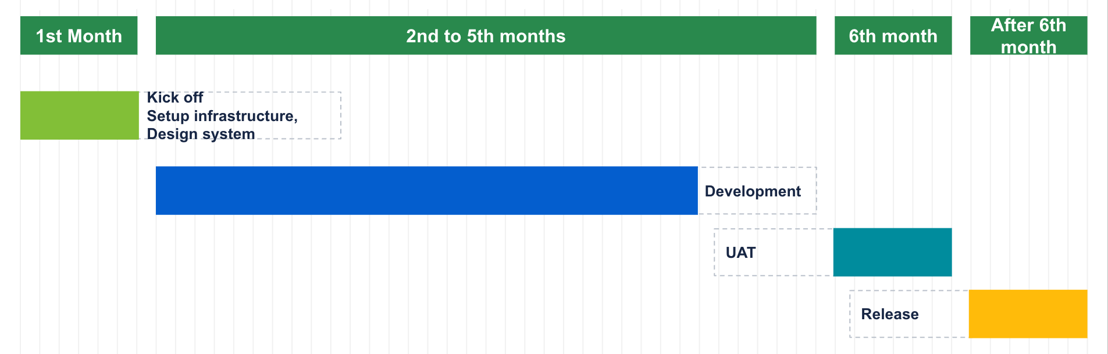

Milestones
- Fleet Management

IFMS
Module | Feature
Milestone 1 | Log in
Milestone 1 | Condition page
Milestone 1 | Privacy Policy page
Milestone 1 | Map features and tools
Milestone 1 | Search bar
Milestone 1 | Individual Vehicles
Milestone 2 | View vehicle list
Milestone 2 | Summary Overview (each vehicle)
Milestone 2 | History Overview
Milestone 2 | CRUD geozones
Milestone 2 | Import geozone
Milestone 2 | CRUD geozone groups
Milestone 3 | Alerts from Vehicles
Milestone 3 | Events Overview
Milestone 3 | Drivers list
Milestone 3 | Drivers Management
Milestone 3 | Event list
Milestone 3 | CRUD event
Milestone 4 | Change password
Milestone 4 | System Language
Milestone 4 | API keys
Milestone 4 | CRUD maintenance task
Milestone 4 | Maintenance tasks List
Milestone 4 | Report Overview
Milestone 4 | Report
Milestone 4 | Export Report
Milestone 4 | GDPR compliance

- Admin panel

Admin Panel
Module | Feature
Milestone 1 | Login/Logout
Milestone 1 | Vehicles List
Milestone 1 | CRUD Vehicles
Milestone 2 | Client List
Milestone 2 | CRUD Client
Milestone 2 | Webusers List
Milestone 2 | CRUD Webuser
Milestone 2 | Sim Cards List
Milestone 2 | CRUD Sim Card
Milestone 2 | Stakeholders List
Milestone 2 | CRUD Vehicles
Milestone 4 | Change password
Milestone 4 | GDPR compliance

Proposed Technology

Development Environment
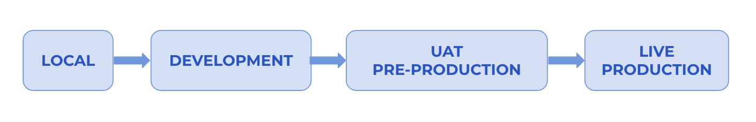
Development Environment

Environment | Purpose
Local | - An environment for developers to develop features, do self testing
Development | - An environment for developers to integrate FE and BE code and self test full features. Developers can invite testers/product owners to review features to ask for early feedback.
Testing/Staging | - A testing environment for tester/product owner to do integration testing and verify all issues before demo.
Live/Production | - Before releasing any version, a full backup of production needs to be prepared. After release, the smoke testing is required. Only some people in the white list IP can access the system and do the smoke testing.

Proposed Workflow

Management Methodology
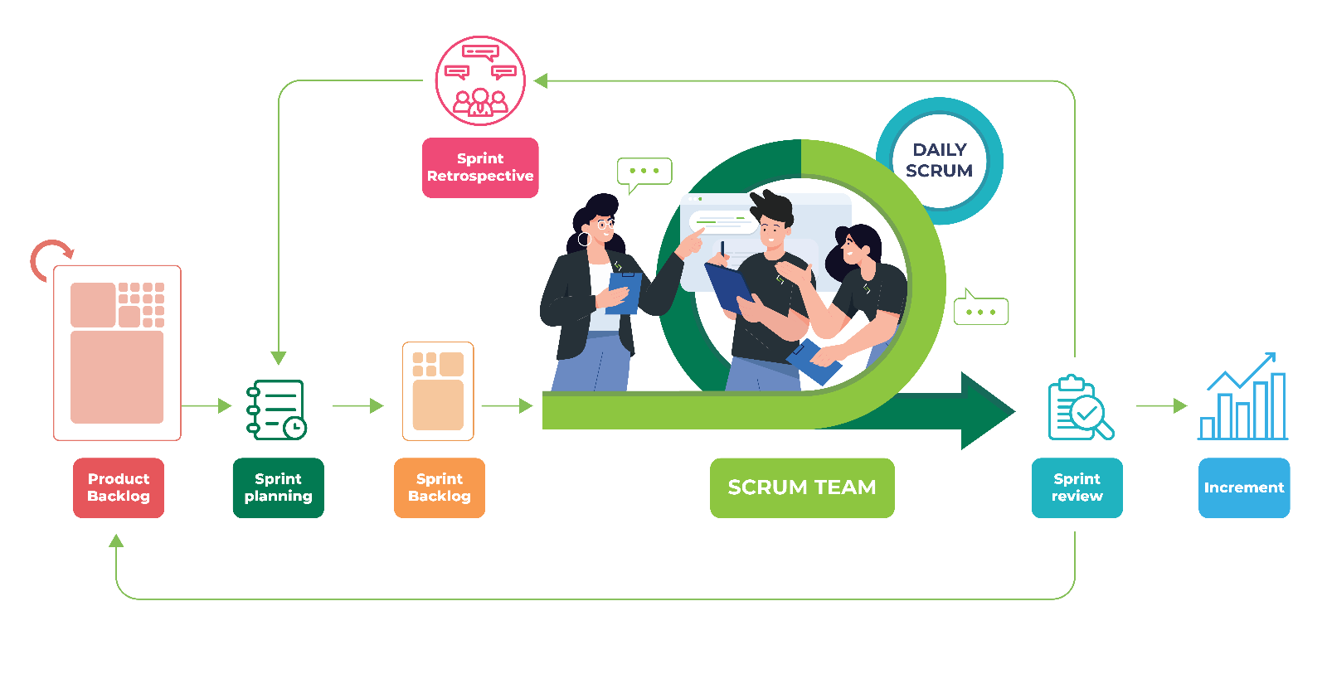
Agile Methodology

- Sprint length: 2 weeks sprint

- Scrum role:
  - Product Owner (Client Project Manager)
  - Scrum Master (Service Provider Project Manager)
  - Development Team
  - Tester

- Project Roadmap:
  - Product Owner and Scrum Master to define the project roadmap and the target for each phase.

- Product Backlog:
  - Scrum master, Product Owner to get raw requirements from Client then transfer them to User Story.

- Release Grooming:
  - Scrum Master, Development Team to break down User Story into Epic and Task.
  - Following the project roadmap, first, define the sprint goal of this iteration, then select a list of user stories/epic/tasks to form the Sprint Backlog for the coming sprint that could fulfill the sprint goal.

- Sprint Planning:
  - Scrum Master, Development Team to review the current tasks, then estimate (Story Point) and arrangements for the workload based on the Sprint Backlog list.
  - Story Point is a scale of 1-13: 1 is very easy, 13 is very difficult.
  - In each sprint, the Development Team should allocate at least 15-20% for coding review and customer feedback/bugs.
  - All questions need to be asked in this state.

- Sprint Backlog:
  - Will be completed by the Development Team.
  - During development time, change requests or bugs may be added by the Product Owner. Scrum Master to review the sprint scope, discuss with the Development Team,extend the current sprint if needed.

- Daily Standup:
  - Within the Sprint, a Daily Scrum Meeting is required and each of the meetings is time-boxed in about 15 minutes.
  - Everyone needs to interact face-to-face with all members to share what they did yesterday and commit to what they want to achieve today. Questions about obstacles or unresolved issues could be raised also.
- Sprint Review:
  - When all tickets in Sprint Backlog are completed, Scrum Master conducts a Sprint Review Meeting. The product owner and the customer must participate.
  - Every member of the Scrum Team will demonstrate to them the working software they have completed and this meeting is very important and must not be canceled.

- Sprint Retrospective:
  - Start at the end of each sprint. During the retrospective, the team self-identifies elements of the process that did or did not work during the sprint, along with potential solutions. Retrospectives typically last 90 minutes and are there to help us incorporate continuous improvement into the team culture and into Sprint cadence.

Design Workflow
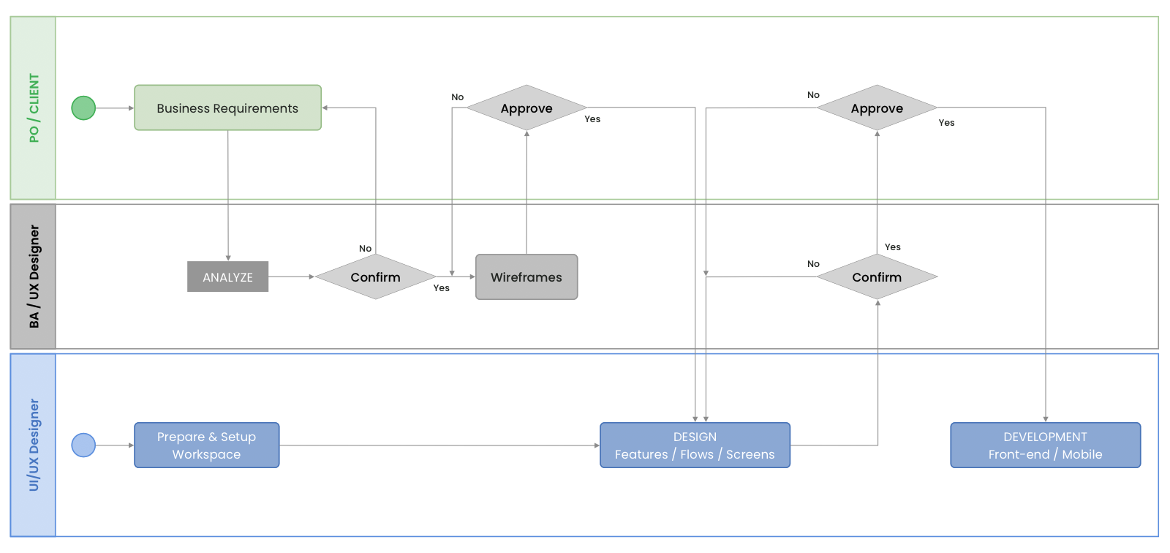
Design Workflow

Phase | Description | Person in-charge
Analyze Requirements | - Clarify the business requirement with PO / Client  - Analyze requirments and confirm them | BA / UX Designer
Confirmation | - Confirm and get approval from PO / Client | BA / UX Designer
Wireframing | - Draw the wireframe base on the confirmation of requirements  - Request the approval from PO / Client | BA / UX Designer
Design | - Design the UI/UX of Features / Flows / Screens  - Request the confirmation from BA / UX Designer and get the approval from PO / Client | UI/UX Designer
Development | - Release the designs to Development | UI/UX Designer

Development Workflow
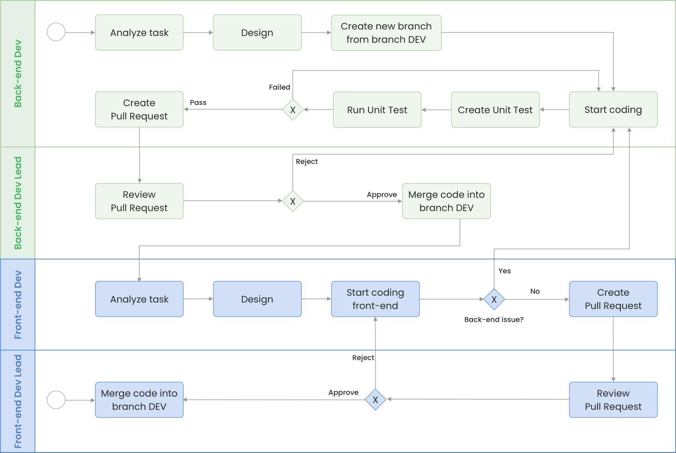
Smartwatch Solutions Ltd Programming Workflow

Phase | Description | Person in-charge
Analyze Task | The developer picks up a task from the Sprint backlog and starts analyze the task::  - Read tickets and clarify with BA, PM/PC, or Client all unclear requirements.  - Review the current project source code (if any) to understand the current context.  - List out all possible test cases.. | Developer
Design | The design solution for the task:  - Define class design, database design, class diagrams, and sequence diagrams (if required).  - Discuss with the Back-end Dev Lead about this solution to finalize the design.  - Define a smaller task list to track progress. | Lead / Tech Lead
Start Coding | Start coding based on agreed design.
Pull Request | Create a pull-request and resolve all conflicts to be reviewed by the Dev Lead and team members. | Developer
Review & Merge Code | Review source code in the pull request based on the style guide or coding convention of the project (must create one for the project).  - Comment on blocks of code having issues and suggest ideas to fix.  - Take note to share this as a lesson learned for other developers if necessary.  Merge feature branch into branch DEV. | Leader / Tech Lead

Testing Workflow

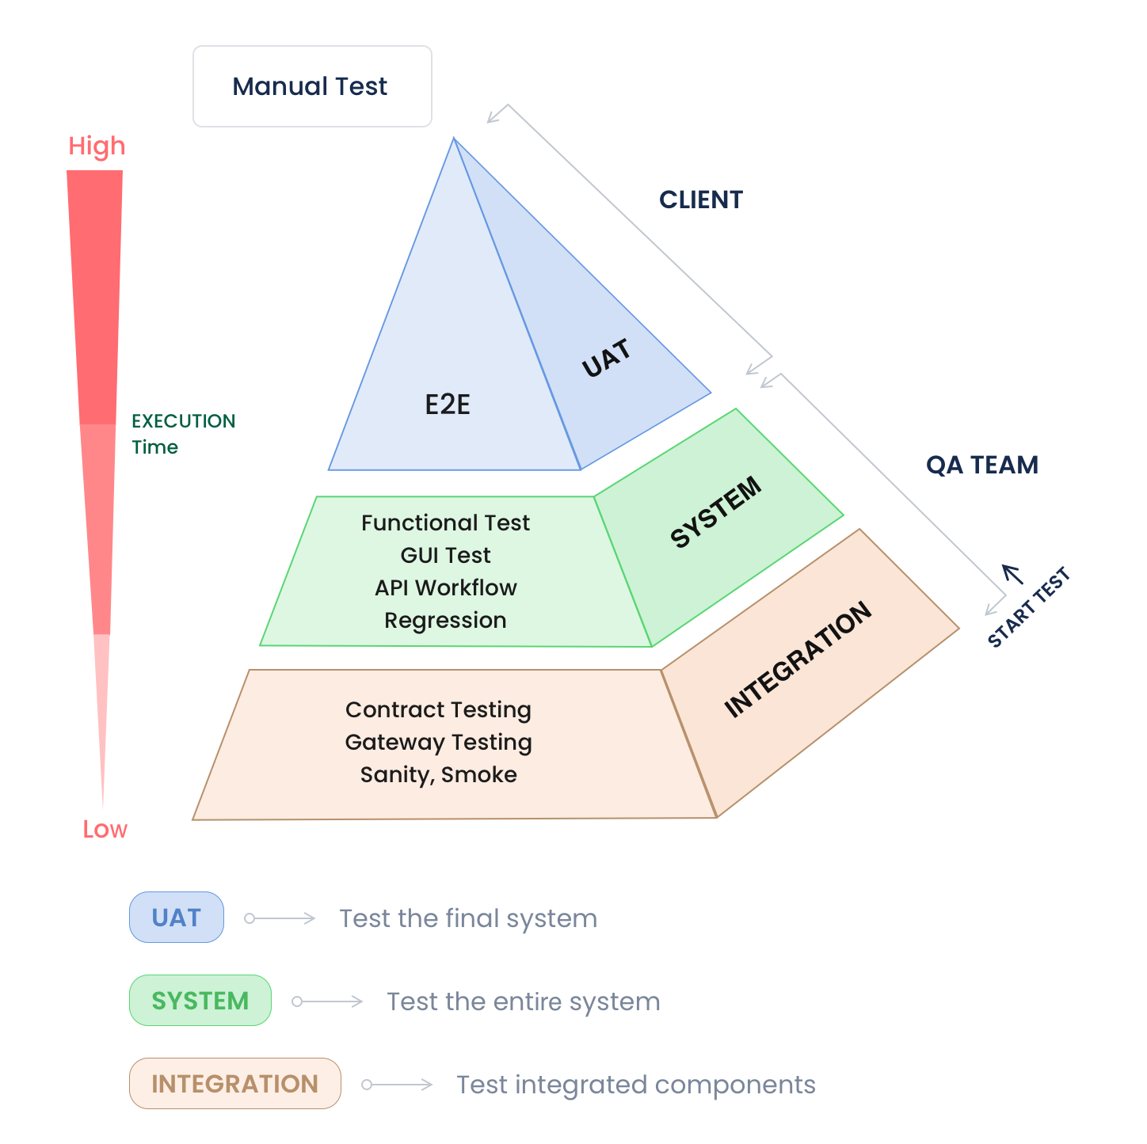
General Testing Workflow

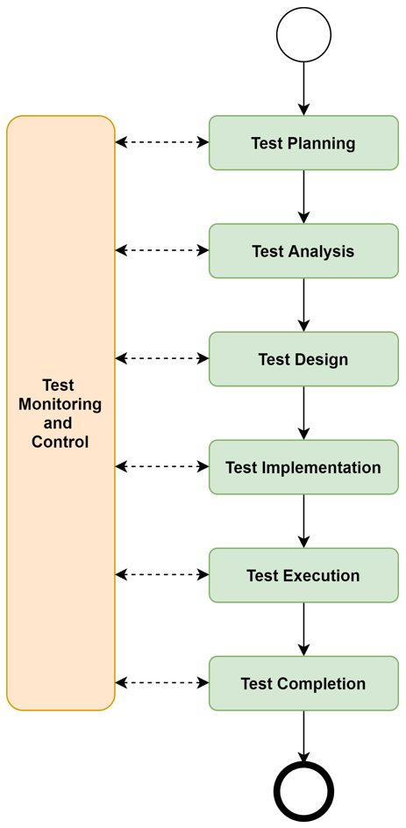 | Test Planning: define a strategy, and planning that includes testing scope, objectives, resources, tools, techniques, and schedule for the testing.
 | Test Analysis: analyzes project’s requirements and specifications to identify testable features, and objectives of the testing.
 | Test Design: design scenarios, high-level cases, data, environment, and techniques based on different expectations are analyzed.
 | Test Implementation: develop test case details, and test scripts (if any) based on the scenarios, and high-level cases.
 | Test Execution: execute tests based on the detailed test cases, test scripts by comparing the actual behaviors against the expectation. Defects and issues are also identified and logged for tracking during this phase.
 | Test Completion: generate final reports, summarize the testing activities, results, and any remaining issues, then send them to stakeholders for release approval or send them back to the development team for fixing.

Testing Scope
Testing to be involved within respective milestones of the development process are shall include:
Testing | Responsibility
Functionality Testing | QC
UI Testing | Client
Integration Testing | QC
GDPR Testing | QC
User Acceptance Testing (test cases as per user stories) | Client

For each user story acceptance criteria are defined.
For further quality assurance, system architecture documentation as well as source code inline documentation is mandatory.
For the testing schedule, please allow two (2) days for client testing for each stage. These days shall be Saturday and Sunday so that feedback can be provided by Monday morning.

User Acceptance Testing
Smartwatch Solutions Ltd recognizes the importance of User Acceptance Testing (UAT) in ensuring the successful delivery of our project. Below are the guidelines for UAT within the scope of our collaboration:
Client Responsibility and Timeline:
- The client is responsible for conducting UAT for each milestone or project.
- UAT should be completed within 14 days from the day Smartwatch Solutions Ltd officially sends the UAT notification email to the client.
UAT Success Confirmation:
  - Following the UAT period with no client feedback, Smartwatch Solutions reserves the right to regard the UAT as successful.
  - Upon successful UAT, Smartwatch Solutions Ltd will proceed to raise the respective invoice.
Bug Resolution:
  - Critical and high bugs identified during the UAT period will be addressed promptly by Smartwatch Solutions Ltd within 3 weeks from the raised date.
  - The resolution of medium and minor bugs will be carried out in a timely manner to maintain the flexibility of deliverables.
Client Rejection:
- In the event of the client choosing to reject the deliverable in the UAT period, the client must provide the substantiated reasons for the rejection, along with validated evidence. Additionally, the determination of the fixed bug resolution time and the UAT period should be deliberated in accordance with the guidelines outlined in User Acceptance Testing.

Working Principle
A set of recommendations that the project team should follow during project implementation.

Smartwatch Solutions Ltd Responsibilities
- Provide a Project Manager for daily project management in need
- Directing the development team
- Daily internal stand-ups
- Briefing and in-day task coordination
- In-development testing
- End of period testing and release coordination
- End of project release, testing coordination
- Document maintenance and reporting
- Clarify requirements: The project manager, team leader, or delegated member of the project is the only one who can receive/confirm the requirements from clients

Client Project Management Responsibilities
- Assign a Product Owner to manage the entire project and product strategy:
  - Analysis of the business.
  - Assistance with wireframe designs.
  - Assistance with data structures.
  - Providing the Development team with functional specifications in detail (e.g. user stories).
  - Providing the Development team with specific non-functional criteria in detail (e.g. hosting).
  - Testing and release coordination after the sprint.
  - Acceptance testing for users.
- During development, the system may be partially deployed to test servers to collect input from clients. Clients must devote time to testing, providing feedback, and correction to the Development Team.
- Clients should give requirements as soon as possible and provide several contact points so that the team can prepare a plan, and resources immediately and proactively contact them to resolve concerns, clarify requirements, and so on. However, there must be just one person who makes and is responsible for the final decision and the confirmation should be monitored in the official communication channel (email).
- The Definition of Done should be defined at the start of the project to keep the process professional and control the quality of the output.

Working Time and Holidays

Working hours:
- Working hours must adhere to the Ugandan time zone (GMT +3), between 8:00 AM to 5:00 PM or 9:00 AM to 6:00 PM

Holidays:
- Both teams must communicate the holiday in advance to assist the other in rescheduling jobs and updating the plan accordingly.
- National holidays in Uganda must be considered public holidays

Management Tool & Communication Channel
- ClickUp - access to the Monday.com to see progress.
- Sketch/Figma - for Wireframes.
- Emails - official confirmation channel.
- Skype/Google chat/Slack/MS Team/WhatsApp - main communication channel.
- Phone calls - for urgent discussion.

Communication Plan
- At least one meeting (30-60-minutes status call) every two weeks should be scheduled to enhance communication between the Smartwatch Solutions/Kayu Technologies and the PIT, as well as to assist in the clarification of requirements.
- Intermediate Demo Meetings at the end of each Development period.
- The Smartwatch Solutions Project Manager provides written progress status reports once in two weeks.

Contract Type and Invoice Procedures
- Contract type: Project-based custom software development.
- Invoice procedures: Send the invoice after UAT for each release (milestone).

Points of Contact
Main contact persons:
Smart Watch Solution
- Contact name: ………………………..
- Position: Project manager
- Company name: Smart Watch Solution
- Email: projects@smartwatchsolutions.com
Trade Mark Africa Ltd Ethiopia
- Contact name: ………………………….
- Position: ……………………………………….
- Company name: Trade Mark Africa Ethiopia
- Email………………………………………………

Acceptance
All prices and terms quoted in this proposal are valid for 30 days from the date of stated on this proposal.
Name: Nicholas Otieno Ogoma  Company: Smart Watch Solution  Position: CE)  Date: ………………………………. | Name: ………………………………………  Company: Project Implementation Team  Position: ………………………….  Date: ……………………………………

